Pilates
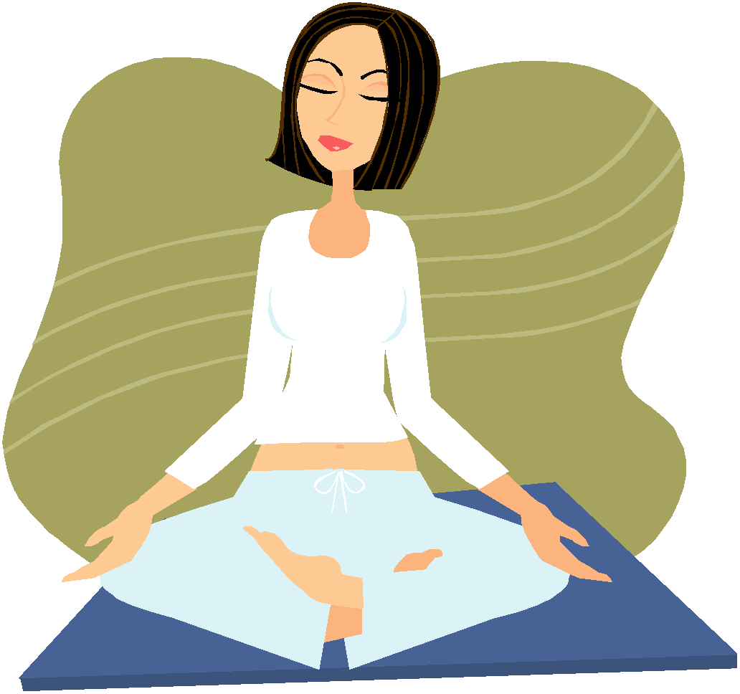
Information sheet for online classes

Pilates (Pi-lart-ees) is a system of exercise that focuses on conditioning your core abdominal and back muscles, therefore improving overall posture, muscle tone and flexibility.

It does this by centring the mind and body around its’ eight principles:
Concentration, centring, breathing, isolation, routine, precision, control and flowing movements.

Pilates was developed in the early nineteen hundreds for use by dancers and athletes. However, thanks to the support of current research, it is now being used not only as an excellent form of non-impact exercise, but also as a very effective form of rehabilitation for low back pain, sports injuries and pre/post pregnancy.

The classes will be taken by a qualified Chartered and HCPC registered Physiotherapist with over 10 years experience, who trained with the APPI (Australian Physiotherapy and Pilates Institute). These Pilates classes will be at a beginner level ONLY, however it is important you stop if you experience any fatigue or discomfort.

If you have enjoyed the class and wish to try one with intermediate level exercises you can contact Mindy Davey on- enquiries@206therapy.co.uk

The following disclaimer applies to these sessions:
As with all fitness and exercise programmes, you need to use your common sense. To reduce and avoid injury, you will want to check with your doctor before beginning any fitness programme if you have any pre-existing medical conditions. The sessions are being supervised but as this is virtual, there is an element of you performing them at your own risk. Two-0-Six and it’s instructors will not be responsible or liable for any injury or harm you sustain as a result of this fitness programme.
Preparing for your class:

- The class will be streamed live from the instructors living room so please forgive the odd cat, dog or child that may join in!

- There may well be some glitches during the first few classes, so please bear with us as we get used to manipulating the technology.

- These classes will be 40-45, beginner level sessions. If you enjoy the class and wish to try a longer class, with intermediate level exercises, you can contact Mindy Davey on: enquiries@206therapy.co.uk

- In order to join in with the class you’re going to need access to a laptop or tablet, phones don’t work well.

- An exercise mat would be useful, as would a folded towel to act as a headrest. It’s best to wear loose comfortable clothes.

- Please spend some time before the class on a platform (WhatsApp/Skype etc) having a play with the best camera positions, sound levels etc so when you join the class so you can get as much as possible out of the session.

- Also think about the best space in your home that allows room for the mat, the ability to fully extend arms/legs and isn’t in direct sunlight.

- The microphones of the participants will be muted during the class in order that the class can run as smoothly as possible. However the instructor will be monitoring the screen so you can wave, or there is a ‘Chat’ function, if there’s a problem during the class.

- For safety reasons we must insist that all participants have their video cameras on throughout the class.

- You will have been asked to fill in a registration form before the class. Can you ensure you have returned that so the instructor can assess whether it is safe for you to take part. You can return registration forms to Mindy Davey on: enquiries@206therapy.co.uk

- If you are in contact with the instructor via the email address above, your details will be dealt with in compliance with GDPR regulations. See the fully Privacy Policy on www.206therapy.co.uk for details.

